**Vance Hall Not interpolated Old Data**

Learning Regression Tree...

Elapsed time is 0.438411 seconds.

Training RMSE(W): 7.47, R2: 0.886, RMSE/peak: 0.0330, NRMSD: 3.77

Learning a cross validated tree...

Elapsed time is 3.848148 seconds.

Cross Validated Training RMSE(W): 12.75, R2: 0.668, RMSE/peak 0.0564, NRMSD: 6.44

Learning a Random Forest...

Elapsed time is 130.485595 seconds.

Random Forests Training RMSE(W): 7.82, R2: 0.875, RMSE/peak 0.0346, NRMSD: 3.95

Testing RMSE(W): 19.53, R2: 0.000, RMSE/peak: 0.1092, NRMSD: 14.02

Cross Validated Testing RMSE(W): 17.50, R2: 0.065, RMSE/peak 0.0978, NRMSD: 12.56

RF (Testing) RMSE(W): 12.82, R2: 0.498, RMSE/peak 0.0717, NRMSD: 9.20

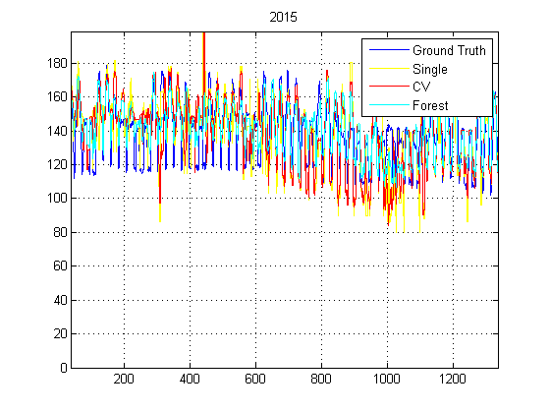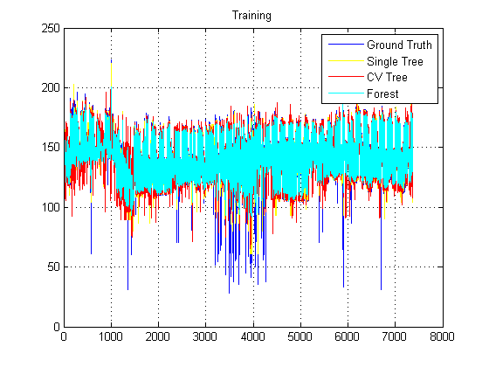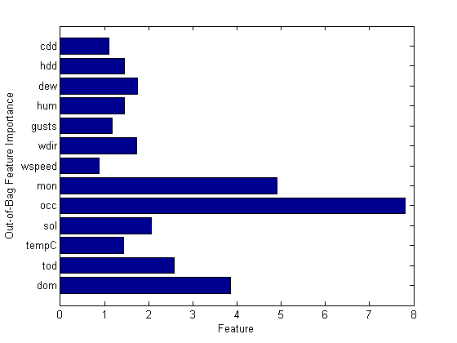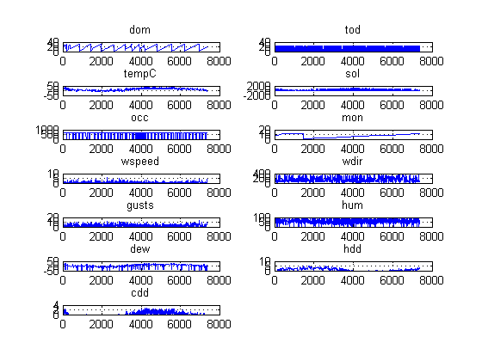

**Vance Hall Interpolated Old Data**

Learning Regression Tree...

Elapsed time is 0.289469 seconds.

Training RMSE(W): 11.65, R2: 0.818, RMSE/peak: 0.0516, NRMSD: 5.89

Learning a cross validated tree...

Elapsed time is 2.526071 seconds.

Cross Validated Training RMSE(W): 16.92, R2: 0.615, RMSE/peak 0.0749, NRMSD: 8.55

Learning a Random Forest...

Elapsed time is 89.426746 seconds.

Random Forests Training RMSE(W): 12.52, R2: 0.789, RMSE/peak 0.0554, NRMSD: 6.33

Testing RMSE(W): 20.35, R2: 0.000, RMSE/peak: 0.1080, NRMSD: 14.52

Cross Validated Testing RMSE(W): 15.81, R2: 0.265, RMSE/peak 0.0839, NRMSD: 11.29

RF (Testing) RMSE(W): 12.97, R2: 0.505, RMSE/peak 0.0689, NRMSD: 9.26

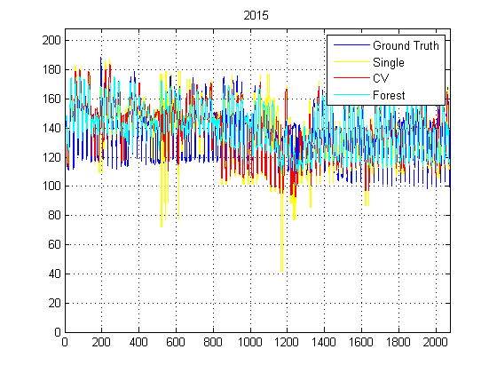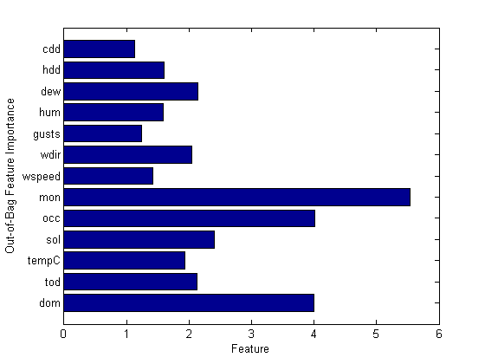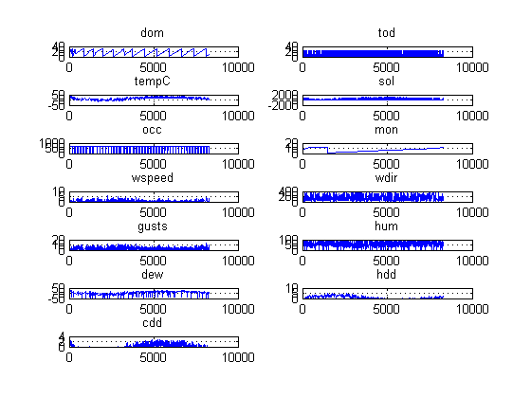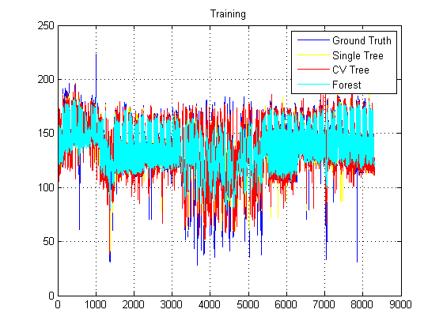

**Vance Hall Interpolated New Data**

Learning Regression Tree...

Elapsed time is 0.346876 seconds.

Training RMSE(W): 20.66, R2: 0.835, RMSE/peak: 0.0530, NRMSD: 6.47

Learning a cross validated tree...

Elapsed time is 3.007260 seconds.

Cross Validated Training RMSE(W): 30.21, R2: 0.647, RMSE/peak 0.0775, NRMSD: 9.47

Learning a Random Forest...

Elapsed time is 107.003158 seconds.

Random Forests Training RMSE(W): 22.30, R2: 0.808, RMSE/peak 0.0572, NRMSD: 6.99

Testing RMSE(W): 42.80, R2: 0.000, RMSE/peak: 0.1206, NRMSD: 15.30

Cross Validated Testing RMSE(W): 37.16, R2: 0.064, RMSE/peak 0.1047, NRMSD: 13.29

RF (Testing) RMSE(W): 31.29, R2: 0.336, RMSE/peak 0.0881, NRMSD: 11.19

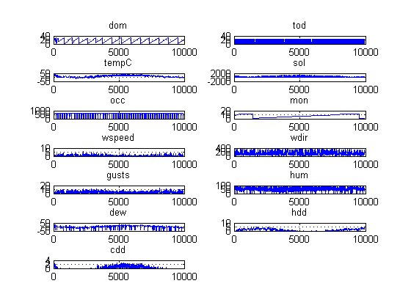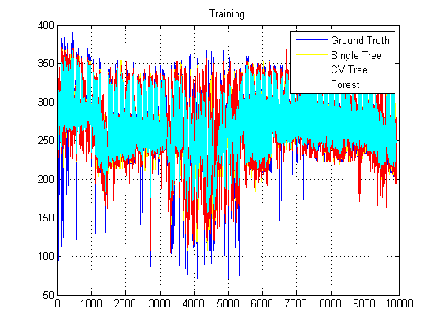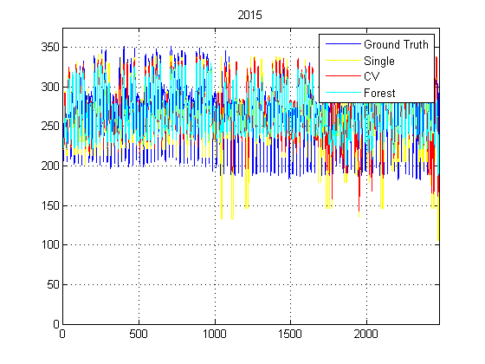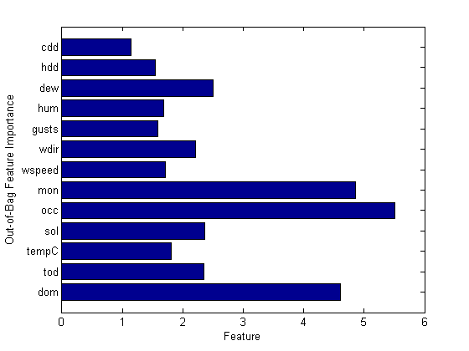

**Vance Hall not interpolated new data**

Learning Regression Tree...

Elapsed time is 0.576501 seconds.

Training RMSE(W): 13.71, R2: 0.899, RMSE/peak: 0.0351, NRMSD: 4.30

Learning a cross validated tree...

Elapsed time is 4.832523 seconds.

Cross Validated Training RMSE(W): 24.17, R2: 0.686, RMSE/peak 0.0620, NRMSD: 7.57

Learning a Random Forest...

Elapsed time is 161.924423 seconds.

Random Forests Training RMSE(W): 14.66, R2: 0.884, RMSE/peak 0.0376, NRMSD: 4.59

Testing RMSE(W): 35.29, R2: 0.170, RMSE/peak: 0.0994, NRMSD: 12.60

Cross Validated Testing RMSE(W): 31.04, R2: 0.358, RMSE/peak 0.0874, NRMSD: 11.08

RF (Testing) RMSE(W): 27.45, R2: 0.498, RMSE/peak 0.0773, NRMSD: 9.80

